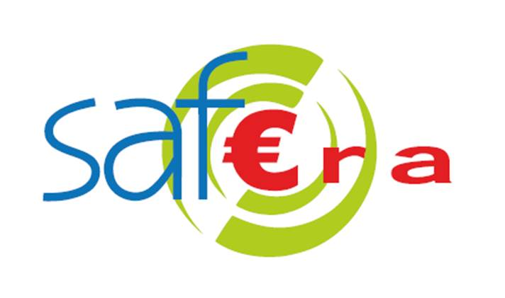 | SAF€RA’s 2022 joint call for proposals  Pre-proposal form

All highlighted text should be replaced by the requested information. The total length of your pre-proposal must not exceed 5 pages (using the 12pt character size already present in this document). Please read the “Guidelines for proposers” document associated with this call before completing this form, and carefully check the information on eligibility criteria.

Note that by submitting your pre-proposal, you allow SAF€RA partners to publish your project title and abstract for institutional reporting purposes.

Title of the project
Project title

Partner organization | Country | SAF€RA funding requested from | SAF€RA funding requested  (k€, approximate)
Partner 1 (coordinator) |  | SAF€RA funder A
Partner 2 |  | SAF€RA funder B
Partner n |  | SAF€RA funder C

Type of proposal:
Transnational consortium proposal
Single-nation proposal

Person responsible for the project (project coordinator)

Surname and first name of the project coordinator
Organization, postal address
Email, telephone, organization web page

Abstract of the proposed research

Provide a summary of:
- the issue or problem addressed
- the way it will be treated (methodology, in brief)
- expected results/outcomes and impact

Issues addressed and relevance

- Define the issues or research questions that your proposal addresses (objectives of the proposal) and any research hypotheses.
- Specify the questions listed in the joint call which are handled.

Please avoid the use of jargon.

Methodology and expected outcomes

Explain:
- the process you will use to handle the issue
- the tasks or steps of this process and partner responsible
- the expected outcomes of these tasks or steps.

Stakeholder impacts

Specify the contribution of the expected outcomes to the issues addressed. Which categories of stakeholders will be interested in your results? If the project is a success, what difference will it make? How could expected results of the project be transferred to stakeholders?

Requested budget

Provide a provisional overview of the budget requested (typically, the number of k€ requested per year will be sufficient information). Note that although this budget is provisional, large deviations between pre-proposal and full-proposal budget requests are not desirable. If an own contribution is available, please specify it.

Please send the completed form in PDF format and .doc or .odt by email to

applications@safera.eu

before 22 September 2022 at 16:00 CET (following deadline extension decided on 31st August 2022). An acknowledgement of receipt will be sent to you by email.

Reminder: the total length of your pre-proposal must not exceed 5 pages in 12 point character size.

For the full list of funding organizations participating in this joint call, please see Annex 1 of the “Guidelines for proposers” document.
Own contribution: any internal funding or in-kind contribution that this partner is able to bring to the project. For example, if a participating researcher’s salary will be paid by your organization whether this project is funded or not, you may state a fraction of their salary (full employer-cost) as an “own contribution”.

