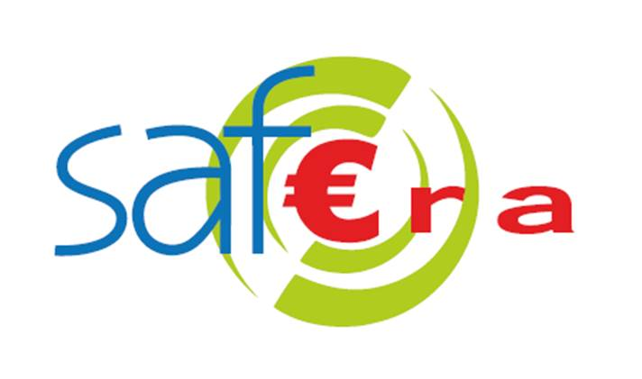 | SAF€RA 2021 joint call for proposals  Response form

PLEASE LEAVE BLANK
Project number:

All yellow highlighted text should be deleted and replaced by the requested information. The total length of your proposal (not including curriculum vitae and the financial annex) must not exceed 15 pages using the 12 point character size that is already present in the document. Please read the “Guidelines for proposers” document associated with this call before completing this form, and carefully check the information on eligibility criteria.

Note that by submitting your proposal, you allow SAF€RA partners to publish your project title, keywords, and abstract for institutional reporting purposes. If your proposal is accepted, you will be required to provide a publishable summary of your proposal to be published by the SAF€RA project as a part of its dissemination process.

Title of the project
Project title

Keywords
List of approximately 5 keywords

Partner organization | Country | SAF€RA funding requested from | SAF€RA funding requested (k€)
Partner 1 (coordinator) |  | SAF€RA funder 1
Partner 2 |  | SAF€RA funder 2
Partner n |  | SAF€RA funder 3

Person responsible for the project (project coordinator)

Surname and first name of the project coordinator
Organization and postal address
Email, telephone and organization web page

Please note that details of the full research team are requested in another section of this form.

Abstract of the proposed research (20 to 25 lines)

Provide a summary of:
- the issue or problem addressed, highlighting which topics in the joint call are addressed
- the way it will be treated (methodology)
- expected results/outcomes and impact
Note that each of these items will be further developed in the following sections.

Issues addressed and relevance (max. 15 lines)

- Define the issues or research questions that your proposal addresses (objectives of the proposal) and any research hypotheses
- Specify the questions listed in the joint call which are handled

Please avoid the use of jargon.

Methodology, task breakdown and expected outcomes

Explain:
- the process you will use to handle the issue
- the tasks or steps of this process and the partner responsible for each task
- the expected outcomes of these tasks or steps

Stakeholder impacts (max. 10 lines)

Specify the contribution of the expected outcomes to the issues addressed. Which categories of stakeholders will be interested in your results? If the project is a success, what difference will it make? How could expected results of the project be transferred to stakeholders?

Innovation (20 to 30 lines)

What is the added value of your proposal with respect to the state of the art or current practice (novelty of the issue or the research question, innovative methodology)? Why do you expect your project will be successful?

Planned schedule

- Specify the total duration of the project.
- Propose a planned schedule for the tasks or steps defined above in the tasks breakdown, for instance in the form of a Gantt chart.
- If relevant, list any specific project risks and briefly identify contingency plans.

Research team

Partner organization 1:

- Role in the project (proposals should clearly identify the specific contribution of each partner in the consortium).
- Persons participating (family name, first name, academic degree, position, discipline and amount of their work time contributing to the project, expressed in person-months).
- Short CV including relevant scientific publications for primary members of the research team (to be included as an attachment).
- Identify whether and how the proposed work is linked with other existing research activities (other research contracts, co-funding).

Partner organization 2: (idem)

…

Partner organization n: (idem)

Please specify how the collaboration between project partners will be organized.

Financial Annex
Provide a provisional indication of the required budget for your project. All numbers provided in this section should include VAT (Value Added Tax). Please specify the currency and unit used for all numbers (suggested unit is k€). Copy and complete the table below once for each partner and include a summary of all costs and funding requested from SAF€RA (see example table below).
If it is more convenient for you to include this information as an extract from your internal accounting software, you may include this annex as a separate document (attempt to provide the same information as in the tables below).

Please contact your funding organization for assistance in completing this financial annex, as some funders may have specific requirements and rules on eligible expenses.

Partner organization 1:

Cost category | SAF€RA funding requested from funding-org 1 (k€) | SAF€RA funding requested in total (k€)
Personnel costs
(briefly explain planned expenses)
2017:
2018:
Year n:
Subtotal:
Travel costs
(briefly explain planned expenses)
2017:
2018:
Year n:
Subtotal:
Equipment costs
(briefly explain planned expenses)
2017:
2018:
Year n:
Subtotal:
Other costs
(briefly explain planned expenses)
2017:
2018:
Year n:
Subtotal:
Overhead costs (if applicable)
(briefly explain planned expenses)
2017:
2018:
Year n:
Subtotal:
Total:

Note: you may specify personnel costs as “real costs including overheads”, or indicate overhead costs separately.

Partner organization 2: (idem)

Partner organization n: (idem)

Example of a summary table:

Partner | SAF€RA funding requested  (k€) | Own contribution  (k€) | Other funding (k€) | Total costs  (k€)
Partner 1 (coordinator)
2018:
Year n:
Subtotal:
Partner 2
2018:
Year n:
Subtotal:
Partner n
2018:
Year n:
Subtotal:
Total:

In cases where requested funding is different from total cost, specify the source and nature of the pre-existing funding or co-funding which is available. Specify your budget per year and per-partner.

Please send the completed form in PDF format and .doc or .odt by email to

applications@safera.eu

before the deadline specified on SAF€RA’s call website. An acknowledgement of receipt will be sent to you by email.

Reminder: the total length of your submission must not exceed 15 pages in 12 point character size (not including curriculum vitae and the financial annex).

SAF€RA funding requested: the funding that this partner is requesting from the SAF€RA funding organizations for this project.
Own contribution: any internal funding or in-kind contribution that this partner is able to bring to the project. For example, if a participating researcher’s salary will be paid by your organization whether this project is funded or not, you may state a fraction of their salary (full employer-cost) as an “own contribution”.
Other funding: any external co-funding that you have already obtained or have the expectation of obtaining for this project. Please specify whether this funding is conditional on any further decisions by another organization.
Total costs should simply be the sum of funding requested, own contribution and other funding. SAF€RA partners will use this information to calculate the leverage effect of funding made available.

